MINISTRY OF INDUSTRY AND TRADE  HO CHI MINH CITY UNIVERSITY OF  FOOD INDUSTRY  Faculty of Electrical & Electronics Technology  No.: ……/KH-DDT | SOCIALIST REPUBLIC OF VIETNAM  Independence – Freedom – Happiness  Ho Chi Minh City, October 17, 2022

PLAN
Organization of the 2023 Flag-Climbing Robot Competition
Pursuant to Plan No. 786/KH-DCT dated November 9, 2018 of Ho Chi Minh City University of Food Industry regarding the organization of academic activities for students;
Pursuant to the overall plan No. 01/KH-DDT of the Faculty of Electrical & Electronics Technology regarding academic activities for students in the 2022–2023 academic year;
The Faculty of Electrical & Electronics Technology develops the plan to organize the 2023 Flag-Climbing Robot Competition as follows:
I. PURPOSE AND REQUIREMENTS
1. Purpose
To create an intellectual and creative playground for students of the Faculty of Electrical & Electronics Technology as well as all students of Ho Chi Minh City University of Food Industry.
2. Requirements
- Students must improve their technical skills, master specialized knowledge, and develop teamwork skills.
- Create a broad learning and research movement throughout the faculty and university.

II. SCHEDULE AND VENUE
1. Schedule: from November 1, 2022 to May 14, 2023
- Practice Day: Friday, May 5, 2023 – All teams must attend the technical parameter inspection in the morning, followed by a practice session on the competition floor for the maximum time stipulated. After the practice session, team representatives will draw lots to determine groups and receive the competition schedule. Any team without a representative present will be considered withdrawn.
- Group Stage: Saturday, May 6, 2023 and Sunday, May 7, 2023.
- Finals and Closing Ceremony / Award Presentation: Sunday, May 14, 2023.
2. Venue: Workshop of the Faculty of Electrical & Electronics Technology, Address: 31 Che Lan Vien, Tay Thanh Ward, Tan Phu District.
III. ELIGIBLE PARTICIPANTS
All students currently enrolled at Ho Chi Minh City University of Food Industry.
IV. REGISTRATION AND REGULATIONS
- Students may freely select team members. Each team has a maximum of 4 members and must designate one team leader as the official representative to liaise with the Organizing Committee.
- Each team registers using the official form and pays a refundable deposit of 100,000 VND to the Organizing Committee at the Faculty Office of Electrical & Electronics Technology, 31 Che Lan Vien, Tay Thanh Ward, Tan Phu District (to ensure registered teams are committed to participating). The deposit will be refunded to teams that participate in the competition; teams that register but do not compete will forfeit the deposit.
- Depending on the number of registered teams, the Organizing Committee will divide teams into groups or use a direct elimination format.

V. IMPLEMENTATION SCHEDULE, CONTENT AND ORGANIZATION
1. Implementation Timeline:
- November 1–15, 2022: Disseminate information to students in all classes.
- November 16–30, 2022: Collect team registration lists.
- December 5, 2022: Finalize the list of participating teams.
- May 5, 2023: Teams conduct practice sessions, draw lots for group assignment, and competition schedule is announced.
- May 6–7, 2023: Opening ceremony and group stage matches.
- May 14, 2023: Finals, closing ceremony, and award presentation.

2. Team Responsibilities: Each team must independently design and build an autonomous robot in accordance with the following specifications:
- Overall dimensions: ≤ 20×20 cm; height unrestricted. After startup, the robot may change its dimensions.
- Weight: maximum 10 kg.
- Power supply is unrestricted.
- The robot may only contact the competition floor through its wheels (all other parts must be at least 1 cm above the floor to prevent damage).
- The robot must move autonomously (line-following or free-navigation) and perform competition tasks without any remote control via laser, infrared signals, etc.

3. Competition Arena:
- The competition arena is a wooden platform measuring 240 cm × 240 cm.
- The arena floor is black with white boundary lines (2 cm wide) surrounding the arena.
- At the center of the arena is a circular confrontation zone with a diameter of 10 cm, enclosed by red metal boundary lines. A plastic flagpole, 30 cm tall, is placed at this position.
- Each team’s robot must be placed at its designated starting line before the match begins.
- A pre-placed white obstacle is fixed in each team’s starting area, measuring 10×10×15 cm and weighing 200 grams (made of foam, screws, or similar material).
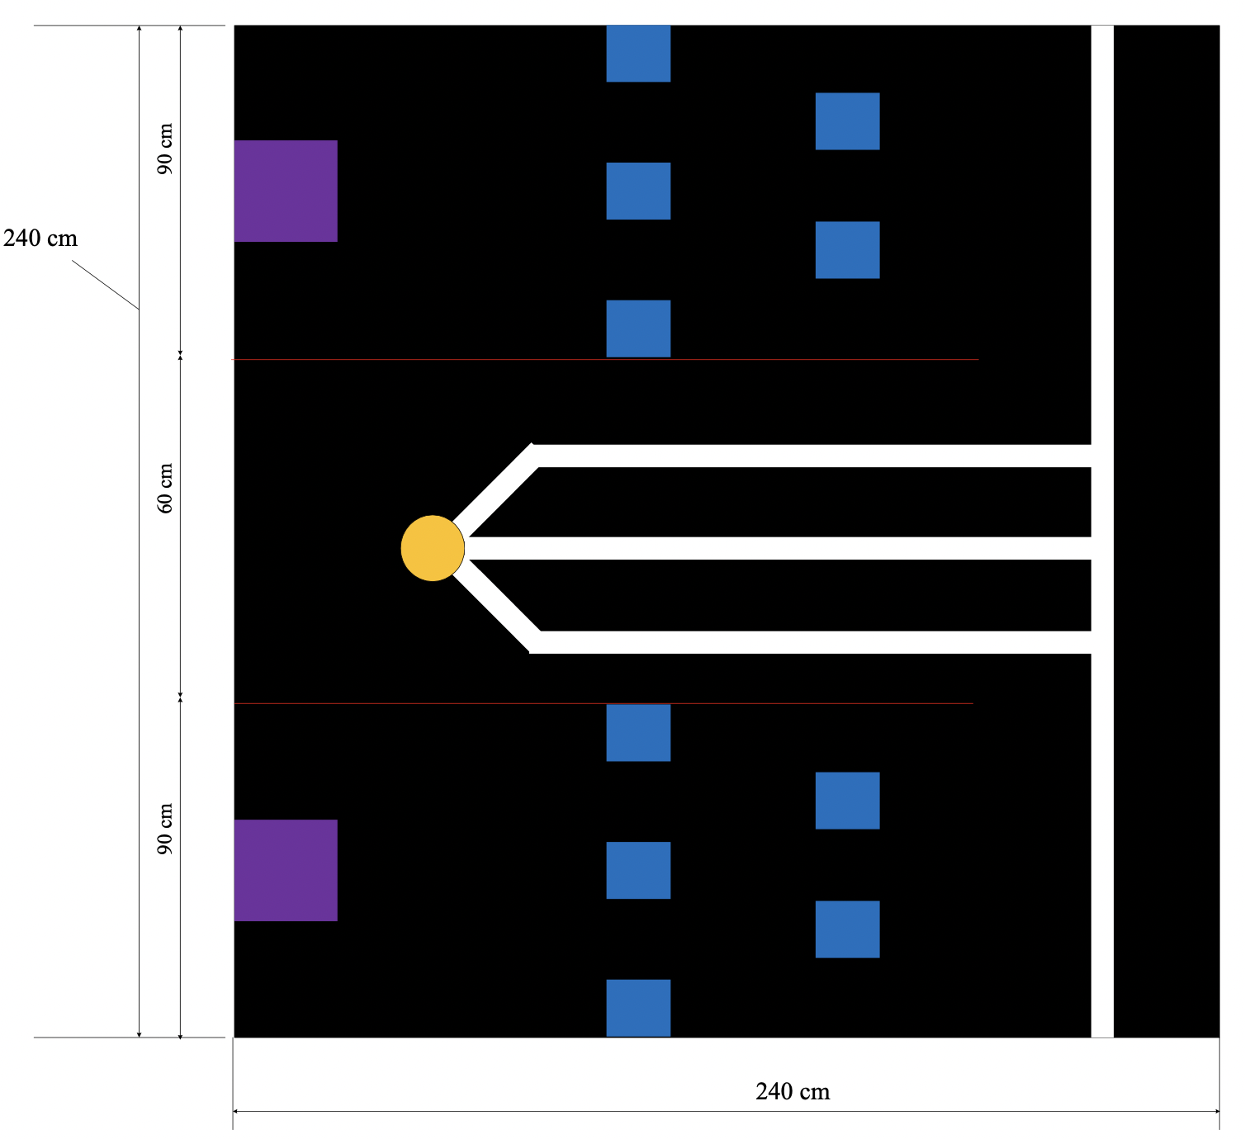
Illustration of the competition arena
4. Competition Rules:
- Each match involves two teams; robots are placed at their respective starting positions. Match duration is 300 seconds (5 minutes).
- Each team selects its starting position by drawing lots before each match.
- Once the referee signals the start of the match, one team member presses the start button for the robot.
- After passing through the “Obstacle Zone”, each team’s robot moves into the “Confrontation Zone” and knocks down the flagpole.
- If time expires without either team’s robot knocking down the flagpole, points are awarded based on accumulated score:
- Robot leaving its team’s “Obstacle Zone”: +2 accumulated points.
- Robot entering the “Confrontation Zone”: +3 accumulated points.
- Robot entering the “Confrontation Zone” but subsequently leaving it: −1 accumulated point.
- Each team’s final score is the total of accumulated points earned throughout the match.
- Each team is allowed one retry (restart) if their robot fails to move (retry is only permitted when the robot is not being interfered with by the opponent’s robot).
- Robots may not use water, chemicals, flammable/explosive substances, or any liquids, and may not emit fire during the match (to prevent damage to the arena) or endanger spectators. Any team violating this rule will be immediately disqualified.
- Other violations not explicitly stated in the rules will be handled at the discretion of the officiating referee. Teams may appeal match results to the Organizing Committee and referee after the match concludes, provided evidence is available.
5. Competition Format:
- Group Stage: Teams play in a round-robin format (single round). A win earns 3 points, a loss earns 0 points, and a draw earns 1 point each. The top two teams from each group advance to the next round. In case of a tie in points, the confrontation coefficient (accumulated points) is used as the tiebreaker. If two teams are tied in the group stage, a direct elimination match will determine who advances.
- Elimination Round: Teams compete in a cross-group format (1st place from one group vs. 2nd place from another group), in alphabetical group order (A, B, C...). In case of a tie, the following tiebreakers apply in order:
- Number of direct wins.
- Total accumulated points during the match.
- Which team scored accumulated points first.

6. Violation Penalties:
- Robot does not meet design specifications (dimensions, weight, etc.): Disqualification.
- Robot starts before the referee’s signal: Match is paused and restarted.
- Intentional use of infrared or laser remote control: Immediate disqualification.
- Team members who engage in disputes or exhibit unsportsmanlike conduct: Immediate disqualification.

VI. PRIZE STRUCTURE
- 01 Champion prize: 4,000,000 VND.
- 01 Runner-up prize: 2,000,000 VND.
- 02 Third-place prizes: 1,000,000 VND each.
- 02 Consolation prizes: 500,000 VND each.

VII. ORGANIZING COMMITTEE

1. Mr. Le Thanh Toi, Deputy Dean in charge | Head of Committee
2. Mr. Ngo Hoang An, Deputy Head of Electronics Department | Standing Deputy Head
3. Mr. Tran Trong Hieu, Lecturer | Deputy Head
4. Mr. Hoang Dac Huy, Lecturer | Deputy Head
5. Mr. Le Minh Thanh, Lecturer | Deputy Head
6. Mr. Le Khac Sinh, Lecturer | Deputy Head

The above constitutes the Plan for organizing the 2023 Flag-Climbing Robot Competition of the Faculty of Electrical & Electronics Technology. All relevant individuals are required to implement the contents of this plan fully and seriously.
Recipients:  - Office of Student Affairs and Educational Inspection;  - Archived at the Department Office. | DEAN OF FACULTY  Le Thanh Toi

