HO CHI MINH CITY UNIVERSITY OF INDUSTRY AND TRADE  FACULTY OF ELECTRICAL & ELECTRONICS TECHNOLOGY  No.: ....../KH-DDT | SOCIALIST REPUBLIC OF VIETNAM  Independence - Freedom - Happiness  Ho Chi Minh City, September 20, 2023

PLAN
Organization of the 2024 Flag-Climbing Robot Competition
Pursuant to the academic year plan 2023–2024 of Ho Chi Minh City University of Industry and Trade;
Pursuant to the academic year plan 2023–2024 of the Faculty of Electrical & Electronics Technology;
The Faculty of Electrical & Electronics Technology hereby develops the plan to organize the 2024 Flag-Climbing Robot Competition as follows:

I. PURPOSE AND REQUIREMENTS

1. Purpose
To create an intellectual and creative playground for students of the Faculty of Electrical & Electronics Technology as well as all students of Ho Chi Minh City University of Industry and Trade.
To train skills and improve technical proficiency for 2nd and 3rd year students majoring in Electrical Engineering Technology and Control & Automation Engineering Technology.

2. Requirements
- Students must improve their technical skills, master specialized knowledge, and develop teamwork skills.
- Create a broad learning and research movement throughout the faculty and university.

II. SCHEDULE AND VENUE
1. Schedule: From September 20, 2023 to June 2, 2024
- Practice Day: Friday, May 10, 2024 – All teams must attend technical parameter inspection in the morning, followed by a practice session on the competition floor within the maximum time stipulated. After the practice session, team representatives will draw lots to determine groups and receive the competition schedule. Any team without a representative will be considered withdrawn.
- Group Stage: Saturday, May 11, 2024 and Sunday, May 12, 2024.
- Finals and Closing Ceremony / Award Presentation: Sunday, May 26, 2024.
2. Venue: Workshop of the Faculty of Electrical & Electronics Technology, Address: 31 Che Lan Vien, Tay Thanh Ward, Tan Phu District.

III. ELIGIBLE PARTICIPANTS
- All students currently enrolled at Ho Chi Minh City University of Industry and Trade.
- Students specializing in Electronics Engineering and Electrical & Electronics Engineering Technology who are completing Project 2.

IV. REGISTRATION AND REGULATIONS
- Students may freely select team members. Each team has a maximum of 03 members and must designate one team leader as the official representative to liaise with the Organizing Committee.
- Registration method: via Google Form link: https://forms.gle/QVj7BrXfLayGDzv9A and join the Zalo group: https://zalo.me/g/kjajss560
- Registration deadline: Round 1: by November 30, 2023; Round 2: by March 30, 2024.
Depending on the number of registered teams, the Organizing Committee will divide teams into groups or use a direct elimination format.

V. IMPLEMENTATION SCHEDULE, CONTENT AND ORGANIZATION

1. Implementation Timeline:
- September 20, 2023 – November 30, 2023: Disseminate information to students and collect team registration lists.
- December 5, 2023: Deadline for team list submission.
- May 10, 2024: Finalize participating team list, draw lots to determine groups, announce competition schedule.
- May 11–12, 2024: Opening ceremony and group stage matches.
- May 26, 2024: Finals and closing ceremony with award presentation.

2. Team Responsibilities:
Each team must independently design and build an autonomous robot in accordance with the following specifications:
- Overall dimensions: ≤ 20×20 cm; height unrestricted. After startup, the robot may change its dimensions.
- Weight: maximum 10 kg.
- Power supply for the robot is unrestricted.
- The robot may only contact the competition floor through its wheels (all other parts must be at least 1 cm above the floor to prevent damage).
- The robot must move autonomously (line-following or free-navigation) and perform competition tasks without any remote control via laser, infrared, or radio frequency (RF) signals.
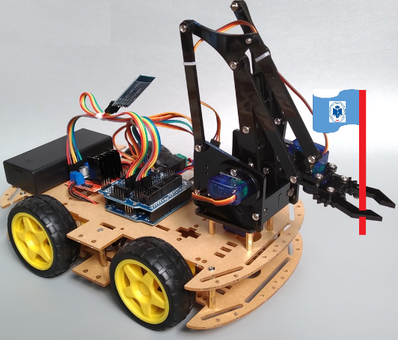
Figure 1. Sample robot with folding arm

3. Competition Arena:
- The competition arena is a wooden platform measuring 240 cm × 240 cm.
- The arena floor is black with white boundary lines (2 cm wide) surrounding the arena.
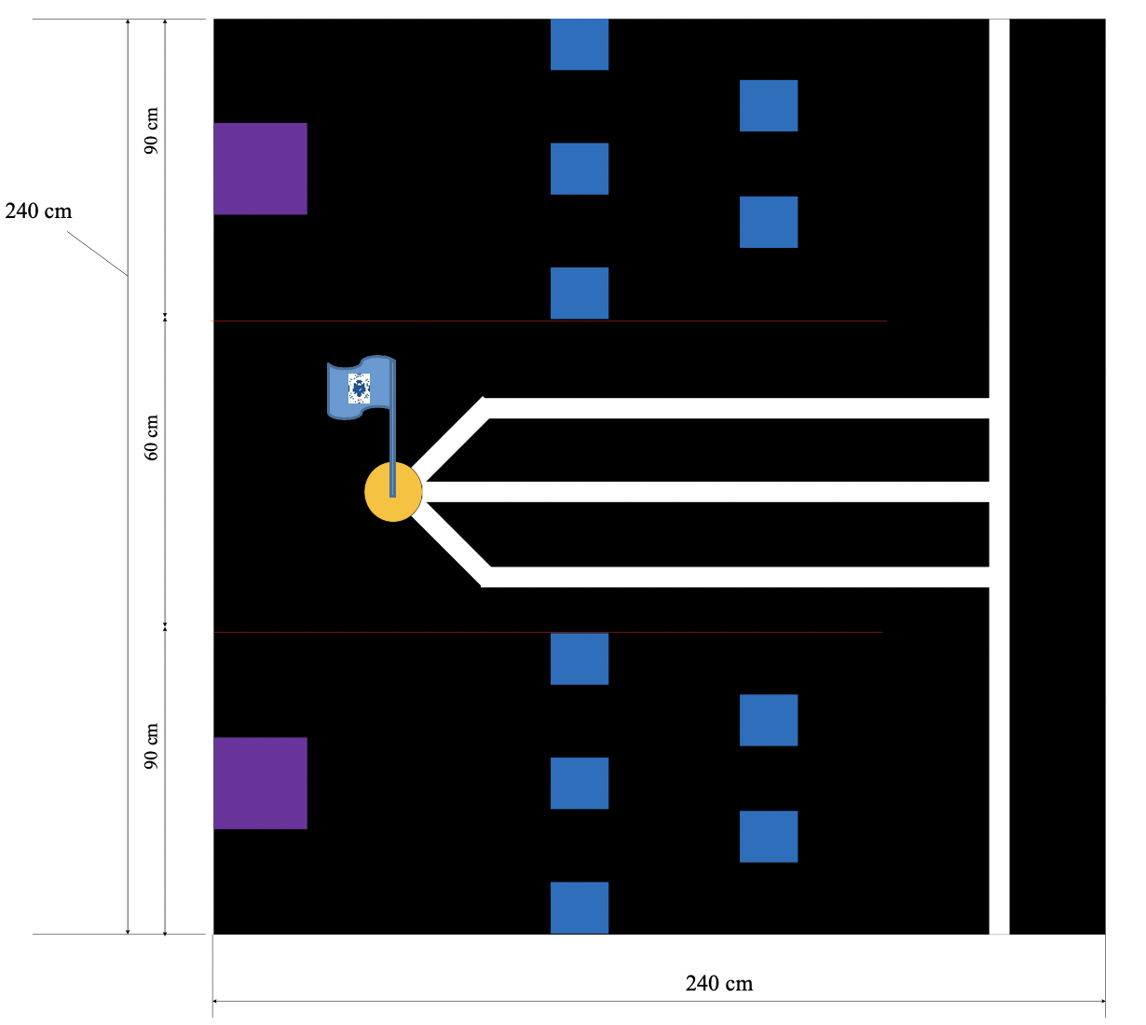
Figure 2. Illustration of the competition arena
- At the center of the arena is a 60 cm × 240 cm confrontation zone enclosed by red metal boundary lines. White guide lines (2 cm wide) lead to the flagpole position, where a hollow plastic cylinder (Ø10 × 15 cm) is fixed. Inside the cylinder is a flag bearing the name “HUIT” (which can be inserted and withdrawn).
- Each team’s robot must be placed at its designated starting line before the match begins.
- Within each team’s starting area, there is a pre-placed white obstacle fixed to the floor, measuring 10 × 10 × 15 cm and weighing 200 grams (made of plastic or similar material).

4. Competition Rules:
- Each match involves two teams; robots are placed at their respective starting positions. Match duration is 300 seconds (5 minutes).
- Each team selects its starting position by drawing lots before each match.
- Once the referee signals the start of the match, one team member presses the start button for the robot.
- After passing through the “Obstacle Zone”, each team’s robot enters the confrontation zone, identifies the flagpole, and attempts to withdraw the flag from the pole (flag capture). The team that successfully withdraws the flag within the stipulated time is considered to have completed the challenge and receives maximum points.
- If time expires without either team completing the challenge, points are awarded based on accumulated score:
- Robot clearing its team’s “Obstacle Zone”: +2 accumulated points.
- Robot entering the “Confrontation Zone”: +3 accumulated points.
- Robot entering the “Confrontation Zone” but subsequently leaving it: -1 accumulated point.
- Robot entering the “Confrontation Zone” and performing flag withdrawal actions: +5 accumulated points.
- Each team’s final score is the total of accumulated points earned throughout the match.
- Each team is allowed one retry (restart) if their robot experiences a malfunction during the match (retry is only permitted when the robot is not being interfered with by the opponent’s robot).
- Robots may not use water, chemicals, flammable/explosive substances, or any liquids, and may not emit fire during the match (to prevent damage to the arena) or endanger spectators. Any team violating this rule will be immediately disqualified.
- Other violations not explicitly stated in the rules will be handled at the discretion of the officiating referee. Teams may appeal match results to the Organizing Committee and referee after the match concludes, provided evidence is available.

5. Competition Format:
Group Stage: Teams play in a round-robin format (single round). A win earns 3 points, a loss earns 0 points, and a draw earns 1 point each. The top two teams from each group advance to the next round. In case of a tie in points, the accumulated confrontation score (total accumulated points across all matches) is used as the tiebreaker. If two teams are tied in the group stage, a direct elimination match will be played to determine who advances.
Elimination Round: Teams compete in a cross-group format (1st place from one group vs. 2nd place from another group), in alphabetical group order (A, B, C...). In case of a tie, the following tiebreakers apply in order:
- Number of direct wins.
- Total accumulated points during the match.
- Which team scored accumulated points first.

6. Violation Penalties:
- Robot does not meet design specifications (dimensions, weight, etc.): Disqualification.
- Robot starts before the referee’s signal: Match is paused and restarted.
- Intentional use of infrared or laser remote control: Immediate disqualification.
- Team members who engage in disputes or exhibit unsportsmanlike conduct: Immediate disqualification.

VI. PRIZE STRUCTURE
- 01 Champion prize: 4,000,000 VND
- 01 Runner-up prize: 2,000,000 VND
- 02 Third-place prizes: 1,000,000 VND each
- 03 Consolation prizes: 500,000 VND each

VII. ESTABLISHMENT OF ORGANIZING COMMITTEE, JUDGING PANEL AND LOGISTICS COMMITTEE

1. ORGANIZING COMMITTEE
The Organizing Committee is responsible for scheduling and conducting the competition in accordance with the plan for each round (group stage, quarterfinals, semifinals, finals).
Name & Position | Role
1. Mr. Le Thanh Toi, Deputy Dean in charge | Head of Committee
2. Mr. Ngo Hoang An, Deputy Head of Electronics Department | Standing Deputy Head
3. Mr. Tran Trong Hieu, Lecturer | Deputy Head
4. Mr. Hoang Dac Huy, Lecturer | Deputy Head
5. Mr. Le Minh Thanh, Lecturer | Deputy Head
6. Mr. Le Khac Sinh, Lecturer | Deputy Head

2. JUDGING PANEL
The Judging Panel consists of 03 members appointed by the Organizing Committee from the following candidates:
Name & Position | Role
1. Mr. Ngo Hoang An, Deputy Head of Electronics Department | Head / Member
2. Mr. Hoang Dac Huy, Lecturer | Head / Member
3. Mr. Tran Trong Hieu, Lecturer | Member
4. Mr. Hoang Dac Huy, Lecturer | Member
5. Mr. Le Minh Thanh, Lecturer | Member
6. Mr. Le Khac Sinh, Lecturer | Member
7. Mr. Tran Thanh Trang, Lecturer | Member
8. Mr. Doan Xuan Nam, Lecturer | Member

3. LOGISTICS COMMITTEE
The Logistics Committee is responsible for designing and printing banners and performing other tasks assigned by the Head of the Organizing Committee during the competition.
Name & Position | Role
1. Mr. Bui Quang Huy, Staff | Head of Committee
2. Ms. Vo Thi Le Phuoc, Faculty Administrator | Deputy Head
3. Mr. Do Thanh Dat, Staff | Deputy Head

The above constitutes the plan for organizing the 2024 Flag-Climbing Robot Competition of the Faculty of Electrical & Electronics Technology. All relevant individuals are required to implement the contents of this plan fully and seriously.
Distribution:  - Students, Lecturers;  - Faculty Archive. | DEAN OF FACULTY  Le Thanh Toi

